Learning + LTM

Weighting: 4/17

Scully, I. D., & Hupbach, A. (2019). Different reactivation procedures enable or prevent episodic memory updating. *Hippocampus*, (August), 1–9. https://doi.org/10.1002/hipo.23159

# Agenda

* What is Learning/LTM
* The article: Different reactivation procedures enable or prevent episodic memory updating
* Motivation and hypothesis
* Method
* Results
* Authors’ conclusion
* Criticism
* Memory models
* Greater perspective

## What is Learning/LTM?

### Learning

1. See *encoding*. 2. The combined effect of all encoding, storage, and retrieval in gradually enhancing the performance of a particular task. [8]

### Memory

Processes by which information is encoded (learned), stored, and retrieved. [8]

### Encoding

Also called *learning*. The incorporation of new information into a memory store, which requires the modification or creation of memory traces. Compare *retrieval*

### Retrieval

The recovery or accessing of stored memory traces. Compare *encoding*. [8]

# The article: Different reactivation procedures enable or prevent episodic memory updating

“Despite compelling evidence that episodic memories are sensitive to post-reactivation manipulations, the exact circumstances leading to memory change have not been conclusively determined. The current study aims to fill this gap by comparing different reactivation procedures and their potential to render a memory vulnerable to memory-modifying interventions.” (p. 2)

“The current study assesses how the specific method of reactivation modulates the impact of new learning on reactivated memories.” (p. 3)

## Hypothesis

|  |  |  |
| --- | --- | --- |
| **Hypotheses/expectations** | **Sudoku (control)** | **AC learning (interference)** |
| **Test** | Testing effect: better AB recall compared to restudy | More protection against interference than restudy* |
| **Restudy** | Worse AB recall than testing | Less protection against interference than testing* |
| **Cue (is it edible?)** |  | More intrusion than no reminder |
| **No reminder** |  | Less intrusion than subtle cue |

*Note: \** Prior studies have not reactivated memories through an additional study trial, and therefore, we cannot make clear predictions about the effects of this reminder on RI or intrusions.

1. ”In the control condition (no A–C learning) we predicted to find a testing effect (Roediger III & Karpicke, 2006), that is, better A-B recall in Session 3 in the test in comparison to the restudy condition.” (p. 3)
2. “For the interference condition, we predicted enhanced intrusions for the subtle reminder in comparison to the no-reminder condition (e.g., Hupbach et al., 2007). If testing fosters list segregation (e.g., Szpunar et al., 2008), we should see reduced intrusions in the test in comparison to the subtle reminder condition (Hupbach, 2015).” (p. 3)
3. “we predict that testing in the current ABAC paradigm will reduce RI.” (p. 3)
4. “we cautiously expect that restudying offers less protection against interference learning than testing.” (p. 3)

## Method

|  |  |  |  |  |
| --- | --- | --- | --- | --- |
|  | | | | |
| n = 38 | n = 42 | n = 38 | n = 38 |
| No reminder + sudoku (control) | Test + sudoku (control) | Restudy AB + sudoku (control) | Cue-word + sudoku (control) |
| No reminder + learn AC | Test AB + learn AC | Restudy AB + learn AC | Cue-word + learn AC |

**ABAC paradigm**

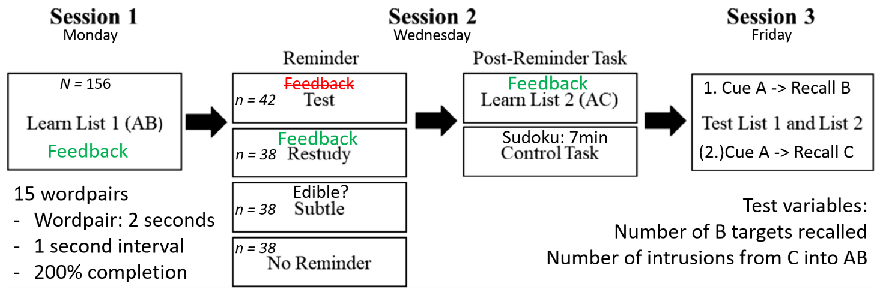

### Figure 1

#### Session 1: List 1 (AB) learning

* All conditions learned list A-B
* 15 word-pairs, each pair presented for 2 s with a 1s inter-stimulus interval
* P received corrective feedback during testing
* The pairs were presented twice in random order. Hereafter P were tested in the lists. Each pair not remembered correctly, would be repeatedly tested in random order, until it could be remembered in its entirety.

#### Session 2: reactivation and/or interference

* Test condition: "In the test condition, participants were presented with the cue words (A) and asked to recall the target words (B) from Session 1." (p. 4)
* Restudy condition: "A–B pairs were presented again, and participants were instructed to relearn them." (p. 4)
* Cue-word only reminder condition: "cue words (A) were presented in isolation one at a time in random order and participants were asked to determine whether the word represented an object that was edible." (p. 4)
* No-reminder condition

Following, Ps *either* learned A-C list or completed control task (Sudoku puzzle)

#### Session 3: final test

* Recall B targets in response to A cues
* If relevant, recall C targets in response to A cues

## Results

### Figure 2: Session 3 results (retroactive interference and intrusions)

#### Legend:

* Dark grey control bar: proportion of List 1 targets recalled in session 3 for participants that performed the control task rather than A-C learning in session 2 across reminder conditions
* Light grey ‘list 2’ bar: proportion of list 1 targets recalled in session 3 for participants that did learn A-C list in session 2 across reminder conditions
* Medium grey ‘intrusions’ bar: proportion of list 2 targets recalled in session 3 when asked to recall list 1 for participants than learned list 2 in session 2 across reminder conditions.

#### Results from figure 2

* Within the control groups, testing, restudy and subtle cue reminders performed the same and outperformed no reminder
* Within AC learning group, testing and restudy performed the same, and both outperformed subtle and no reminder groups
* Sudoku group and AC learning group are different in all other conditions than testing
  + Suggesting that testing protects against RI
* Cue and no reminder conditions had more intrusions from AC to AB than test and restudy conditions

### Figure 3: test condition control

Considers only test condition.

* Control: performed better in session 3 than in session 2, no interference (nothing to interfere)
* L2 learning: performed worse in session 3 than in session 2, retroactive interference

### Figure 4: proactive interference (session 3 test of AC)

* List 1 did not intrude into the later learned list 2
* Rules out general source confusion as an explanation for intrusions (in either direction)
  + Participants likely actually remember AC words as belonging to AB pairs

## Authors conclusions

* Direct reminders (test or restudy) can limit retroactive interference and intrusions
* Indirect reminders ‘expose’ memories to changes
* The more comprehensive the reactivation the smaller the likelihood that the reactivated memory will be “contaminated” with and impaired by new information.
* Direct reminders likely strengthen memory and draw attention to event differences and thereby enhance event segregation.”

## Criticism

* Possibly no true ‘no reminder’ condition as the presentation of A words in AC learning may have served as testing condition by triggering memories of AB.
* What’s “subtle” and what’s “direct” activation of memories? Need more measuring point for this knowledge to be applicable. Or can it only be deduced post hoc?
* Are we really looking at episodic memory?
  + Participants *might* need to remember when they learnt B compared to C to distinguish them when presented with A
  + But is the specific memory of the episode necessary? Maybe they can be stored as 2 different pairs?
  + Control group performs a delayed cued recall (def not episodic)
  + Tulving: participants can recall the episodic memory of an item appearing in the list (autonoetic) or just know that they are a pair (noetic)
* ABC learning? Did participants connect C to B and ‘add on’ to their existing memory?
* LTP / LTD - With practice comes perfect. The associations are strengthened each time it is rehearsed. Testing and restudy conditions have rehearsed list 1 more time than subtle or no reminder has.

## Perspective

* Cowan’s model of working memory (LTM and STM operate on same tissue)
* Baddeley’s multicomponent model
* Atikinson & Shiffrin: stage model
* Craik & Lockhart: Four levels of processing; Structural, phonemic, categorical, semantic
* Forgetting: decay, interference and retrieval failure
* Free recall: Concrete vs abstract words. Primacy and recency effect.
* Ebbinghaus: Forgetting and learning curve.
* Wernicke’s area (you need to be able to understand the words; otherwise it might be quite difficult to remember them… ☺)
* Hippocampus and amnesia
* Brown-Peterson task
  + Trigram of letters -> interference task (counting backwards in threes) -> recall trigram
  + Proactive interference: performance decreases following each trail, but when task is changed, performance increases back to baseline
* **Models for organization of knowledge**
  + **Classical theory (defined properties/features)**
    - Each category defined by a set of features which are necessary and sufficient
    - If an object matches enough features, it is deemed a member of the category
    - Objects have all-or-nothing memberships in a category
  + **Prototype theory**
    - Categories are defined by a prototype
    - Each category has a “most central member” to which all objects are compared
    - If an object is sufficiently similar it is deemed part of the category
    - Couch is more central to the “furniture” category than wardrobe
    - Categories are “graded” -> members near the “edge” can be part of several overlapping categories
    - A prototype can be an averaged version of all members of a category
  + **Exemplar theory**
    - Categories are based on all previously experienced objects which fit in them
    - New objects are compared to exemplars in a category and deemed a member if sufficiently similar
    - Some objects in a category are more typical and share more characteristics with other members -> these may be used as exemplars when making quick judgements or recalling the first few items in a category (fruit: apples and bananas mentioned before figs and dragon fruit)
  + **Explanation-based theory**
    - Categorizing is problem solving: people develop explanations for *why* something is in a category
    - Categories are used and created to explain the world
    - Categories are not just lists of properties but relations between them – birds have
    - Very flexible categories
    - Psychological essentialism: a painted horse is not a zebra – category members are believed to share common essence